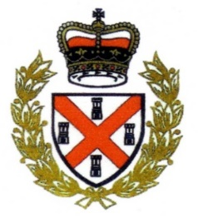
ROYAL PLYMOUTH CORINTHIAN YACHT CLUB
25 The Parade, The Barbican, Plymouth. PL1 2JN
07920 233621
Email: info@rpcyc.co.uk

MEMBERSHIP APPLICATION DEAL FOR SUTTON MARINA BERTH HOLDERS-
Free family membership until Jan 31st 2022

Applicant 1 Applicant 2
Title……………………………………………… Title…………………………………………
Forenames…………………………………….. Forenames………………………………...
Surname……………………………………….. Surname………………………………….. Occupation…………………………………….. Occupation……………………………….
Telephone number……………………………. Telephone number……………………….
Mobile…………………………………………... Mobile…………………………………….
Email……………………………………………. Email……………………………………….
Address……………………………………….. Address……………………………………
………………………………………………… ……………………………………………..
………………………………………………… ……………………………………………..
Post code……………………………………... Post code………………………………….
Any dependents names and DOB………………………………………….
……………………………………………………………………….
I wish to apply for my free membership

Boat Name …………………………. Boat type and size…………………………….. Berth No……..

I/We (the applicant/s) agree to conform to all the Rules and Regulations of the Royal Plymouth Corinthian Yacht Club Ltd and agree to my information being kept securely by RPCYC in accordance with current Data Protection Legislation.

Please verify willingness for us to contact you via
Email Yes/No Mail Yes/No Text Yes/No WhatsApp Yes/No Phone Yes/No

Signature of Applicant …………………………………….. Date……………………………….

Signature of Applicant …………………………………….. Date……………………………….
Return to Neil Morton. Hon. Membership Sec. 25 The Parade, The Barbican, Plymouth PL1 2JN
Ideally edit and send back to Info@rpcyc.co.uk or print off fill in scan/photograph and send back.

